Installation Procedure with Expo Client

Clone the project and unzip the folder

Quick start Clone or download this repository to your computer. Change into the directory that was just downloaded. To setup the required libraries and initialise the application you must run:

npm i

npm start

If you get an error, install npm i -g expo-cli as it is required.

The browser would be opened automatically

There will be an expo cli opened in the browser with all options such as QR code, Run in Device or simulator shown in the image.

Also, select the connection as tunnel and the mode as Production

And you will be get a QR Code below as shown in the image

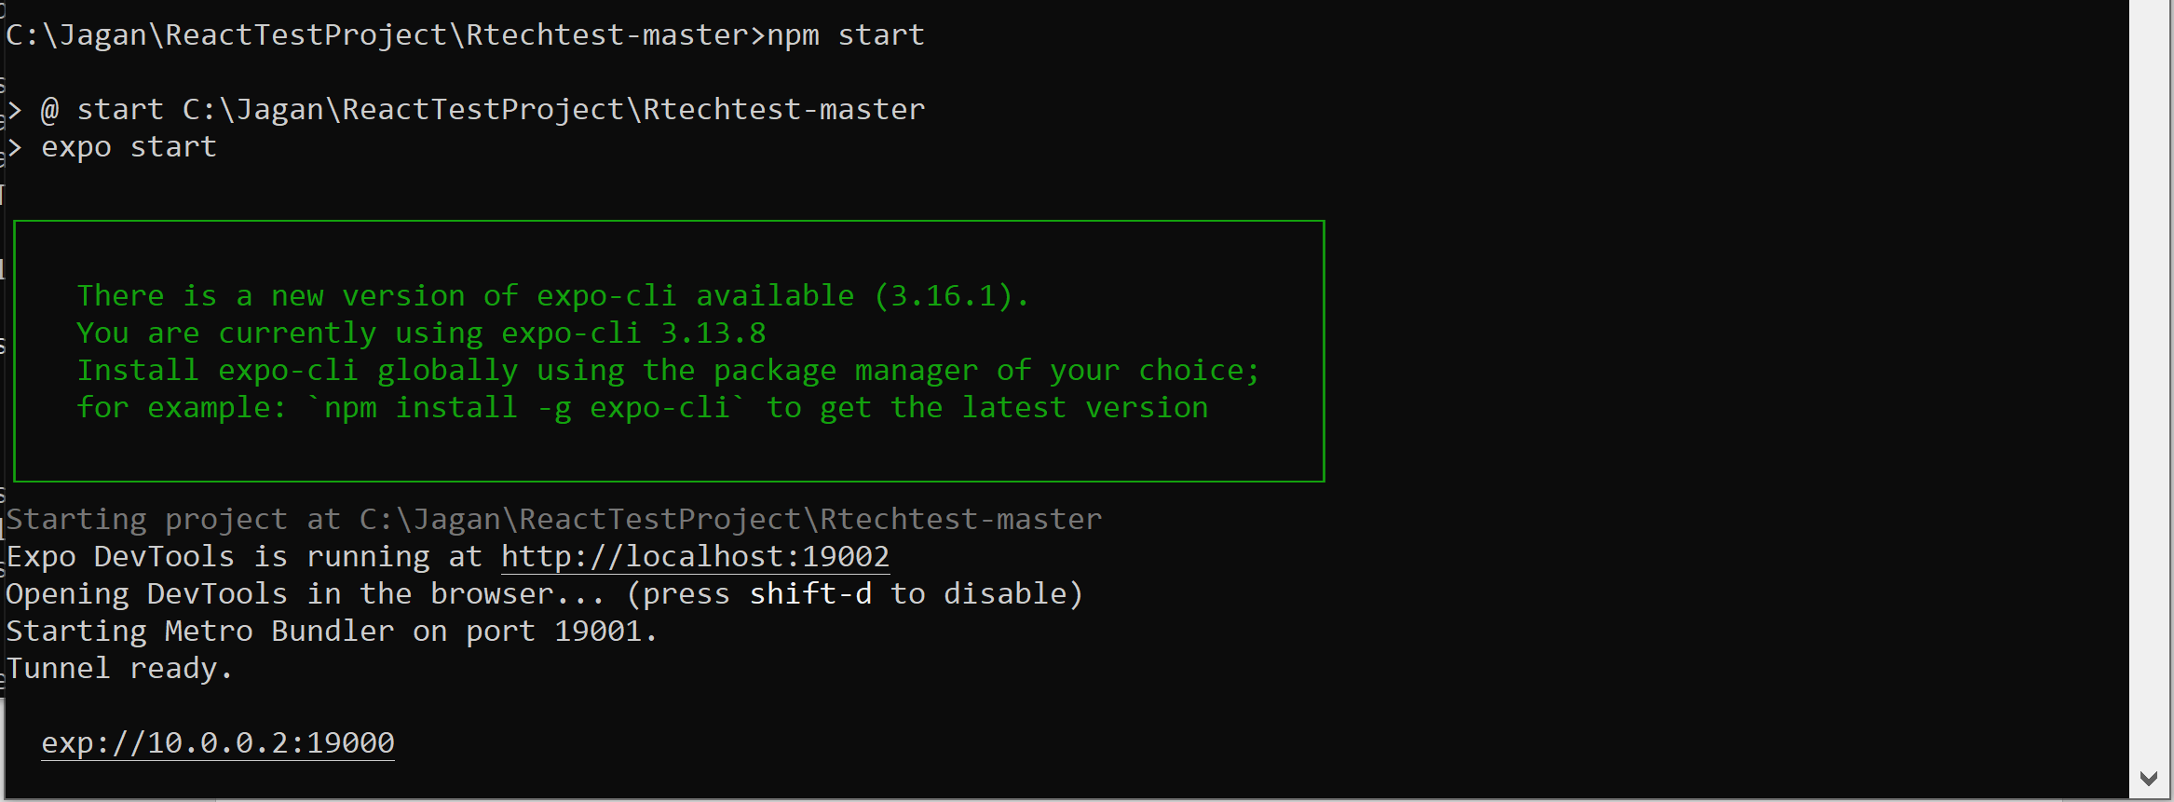

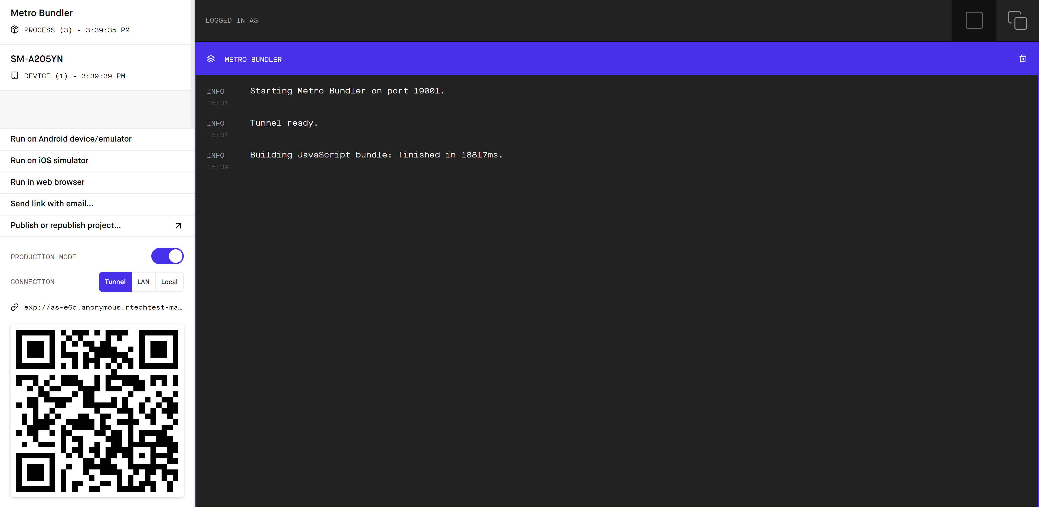

RUN THE APPLICATION IN ANDROID OR IOS

To run the Android Application, download the Expo Client App from Play Store from the below link <https://play.google.com/store/apps/details?id=host.exp.exponent&hl=en_AU>

To run the iOS Application, download the Expo Client App from App Store from the below link <https://apps.apple.com/au/app/expo-client/id982107779>

Click on Scan QR Code and scan the image from the browser as shown below

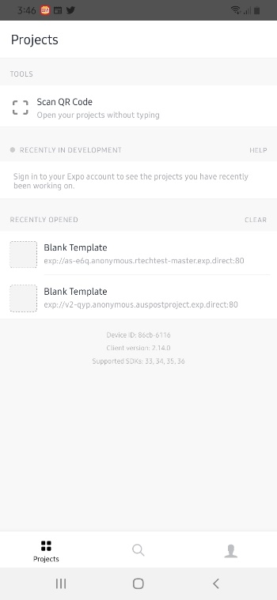 

The Project will be bundled automatically.